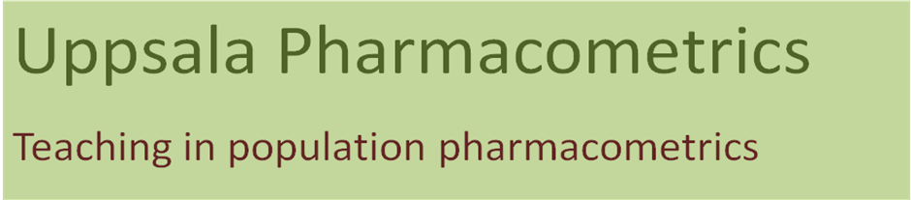

Pharmacokinetic-Pharmacodynamic modeling of continuous and categorical data in NONMEM 7
San Luis Obispo, California, USA, June 17-19, 2010

Thank you for the interest in the course. Please complete the application form and return to Radojka Savic at rsavic@stanford.edu. An invoice will be sent and your final registration will be made once the course fee is paid. The course fee has to be paid at least 2 weeks before the start of the course. You may contact us at rsavic@stanford.edu if you have questions. We look forward to seeing you in San Luis Obispo.

Course Application Form
NAME*
AFFILIATION/COMPANY*
CONTACT ADDRESS*
TELEPHONE NUMBER
EMAIL ADDRESS*
INVOICE ADDRESS*
PURCHASE INVOICE NUMBER*
*Required

